*“There is no denying that there is evil in this world but the light will always conquer the darkness.” ―****Idowu Koyenikan***

**Problem Statement:**

Crime is worst plague for any country. Not only it negatively affects sentiments and emotions of people but also it affects country’s economy. Higher crime rate has detrimental impact on Country image which affects economy by reduced investments/ downfall in tourism etc. So, it becomes imperative that country/state/city need to effectively monitor their crime rate and work towards minimizing the crime for betterment of society.

For this, each unit (city/district/neighborhood) can learn from the past data to identify patterns, insights on crime, so that they can effective:

* Do proactive monitoring in high alert zones
* Optimize police force intake
* Forecast

We have extracted Crime data for Denver, US city in following format:

* Crime data in XLS file **(~500K records for last 5 years)**
* Crime data in shp (spatial file) for Geo Codes
* Crime Report in PDF file

These data files collectively provide following information on crime since 2014:

* Offence Details
* District number
* Neighborhood Name
* Geo codes – Latitude/Longitude
* Date and time of Crime
* Police officers deployed in each district per year (in PDF file)

With this data, following descriptive statistics and Insights I have tried to uncover using Tableau Visualization:

1. Top 5 Crimes in City and details, including Monthly trend
2. Top Districts having maximum Crime
3. Taking top 2 districts and explore the Top crimes in these Districts
4. Which Month/Time these Crimes are most?
5. Visualizing Location **clustering using geo codes and Spatial File**
6. Compare the Crime rates in 3 months and Police officers Deployed in each district. Extracting Police Officers data from **PDF file in Tableau**
7. Forecasting of Crime, **using R**
8. And **Finally using Flask,** exposing Tableau Dashboard over internet.

**Solution:**

1. **As per the Visualization, we can infer that following are the Top 5 crimes in Denver Area:**

|  |  |
| --- | --- |
| **Position** | **Crime Name** |
| 1 | Traffic- Accident |
| 2 | All Other Crimes |
| 3 | Public Disorder |
| 4 | Larceny |
| 5 | Theft from Motor Vehicle |

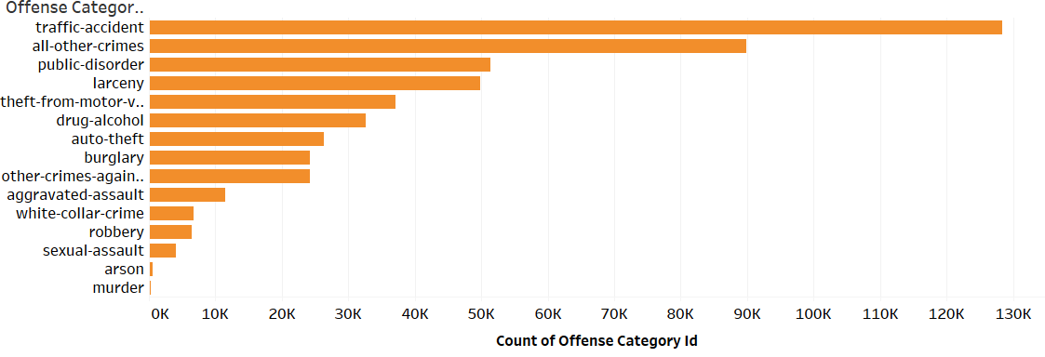

1. **Monthly Trend of top 5 Crimes across Years:**

|  |  |  |  |  |  |
| --- | --- | --- | --- | --- | --- |
| **Crime** | **Year-2014** | **Year-2015** | **Year-2016** | **Year-2017** | **Year-2018** |
| Traffic Accident | Oct | Oct | Oct | Oct | Oct |
| Traf – Others | March | Jan | Jan | Jan | Jan |
| Public Disorder | July | Aug | May | Aug | May |
| Larceny | August | Jun | Aug | Aug | July |

**Few Patterns we can see:**

* Traffic Accidents are peaked every year in October – Why?? We can understand the data behind it, Holiday period or something else, to identify root cause so that Proactive monitoring can be done in the month of Oct.
* Similar Behavior for “Traf – others” for the month of Jan
* “Public Disorder” and Larceny happening maximum in Summers May to August

**So definite patterns we have uncovered**

1. **Next Analysis on Districts i.e. Which district is most notorious and what crimes are common in each district:**

As per below chart, District 3 is most notorious followed by district 6.

Now we shift our focus on these 2 districts and see what crimes are most common in these 2 districts and if there is some pattern

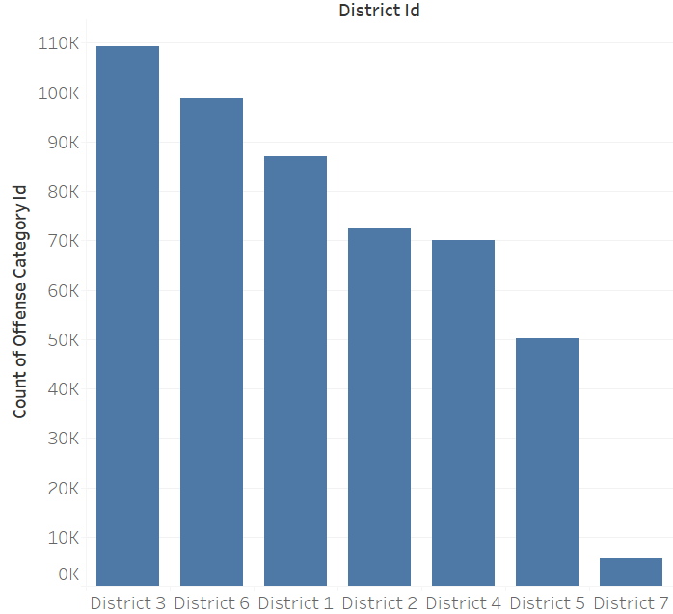

|  |  |
| --- | --- |
| **District#** | **Common Crime** |
| 3 | Traffic Accident |
| 6 | Drug Alcohol (After Traffic Accident) |

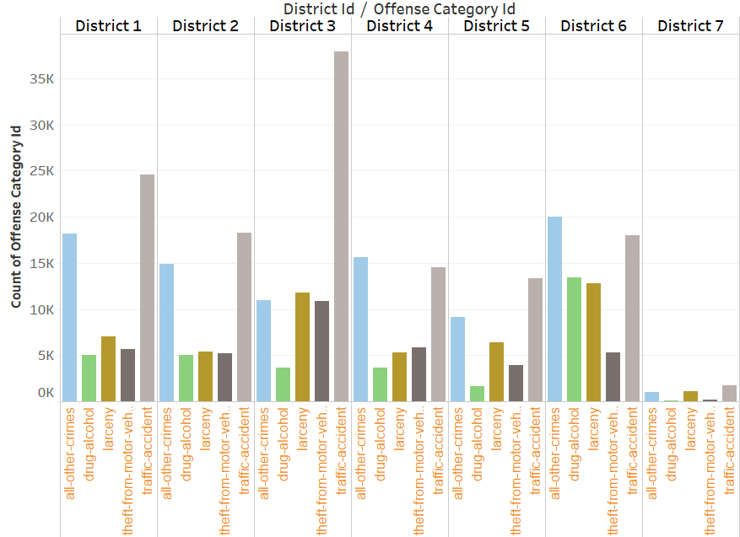

In District 3, top 3 Neighborhoods where most of Traffic Accidents are happening:

* Baker
* Hampden-South
* Speer

**Need more proactive monitoring on these neighborhoods**

1. **More Insights in District 3:**

* Plotted Hourly trend of Traffic Accidents in District 3 revealed that most of the traffic accidents is happening between **4:00 and 5:00 PM**

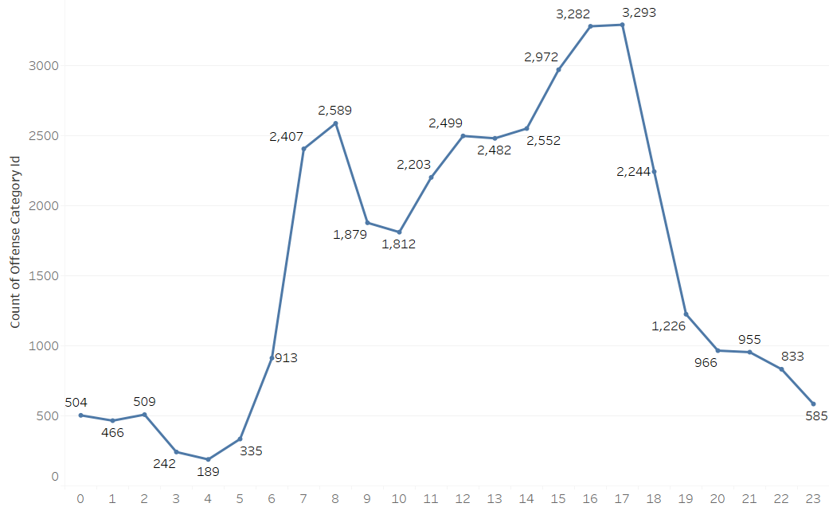

* Month wise, Traffic accidents historically was higher in **Oct for Year 2014, 2015, 2016**, but in year **2017 and 2018 May month** was highest to record Traffic accidents.

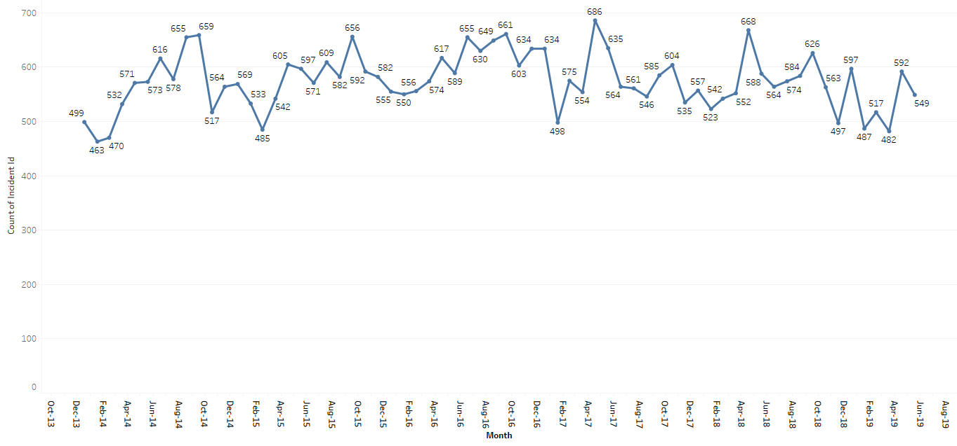

* Plotted Location wise view of Traffic Accidents, reveals concentration in North-West between

N-Valley Highway and East Speer Blvd N – please see the location Geo map in twbx file.

1. **More Insights for District 6:**

* Top 3 Neighborhoods in District 6 having “Drug Alcohol” Crime:
  + Cbd
  + Civic-center
  + Cheesman-park
* Evening 4:00 is the time when maximum Drug related crime happens:

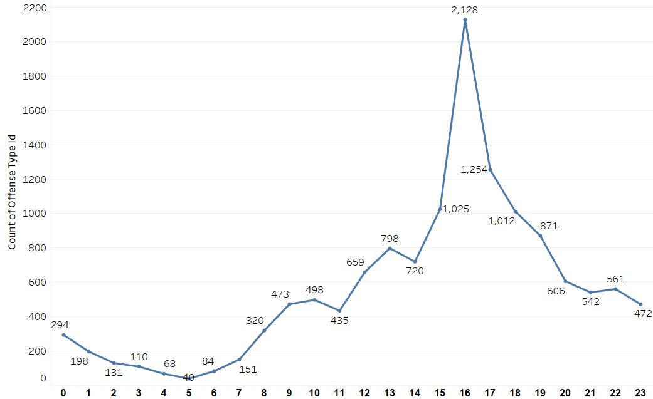

* Location wise, most of the crimes are concentrated at the center of the district – as per the Geo map in twbx file.

1. With the data extracted from PDF file, we have the record of “Police Force” used in 2016,2017 and 2018 in all 7 districts.

So, we can compare if # of crime records (excluding Traffic Accidents) in these districts across 3 years is showing some pattern with # of Police Force Used?

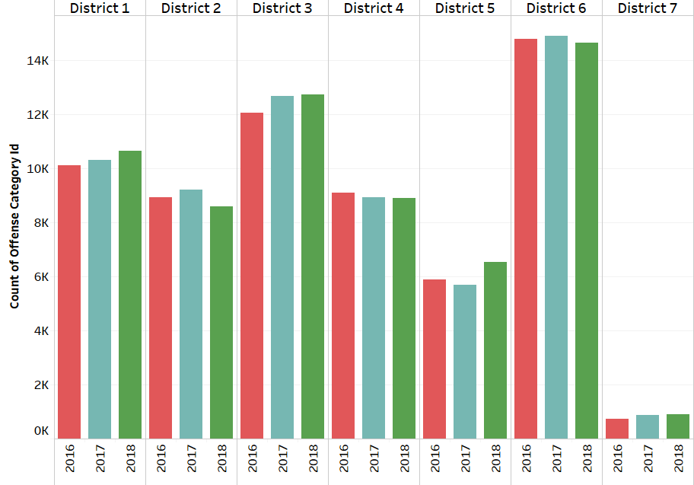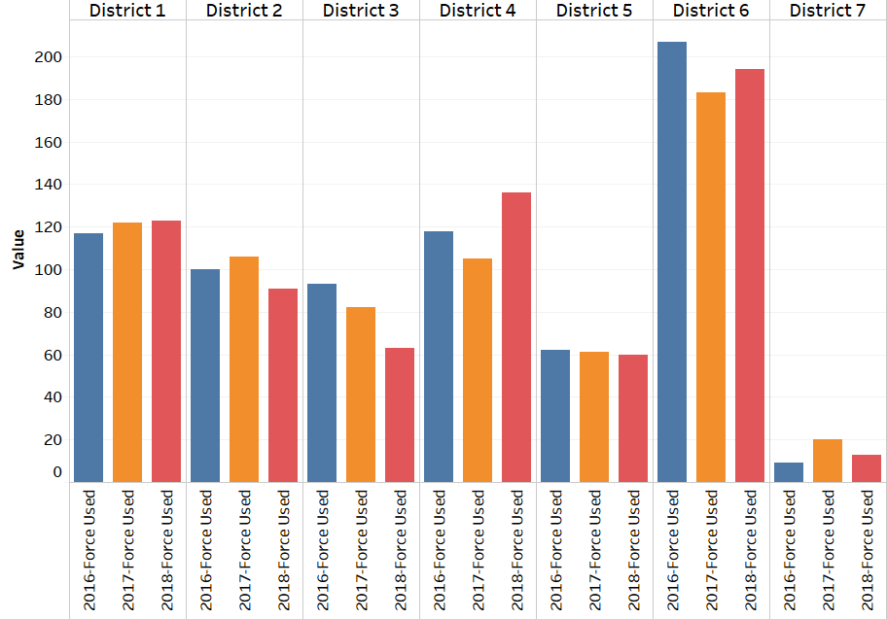

We can see that there is almost linear relationship between crimes across district and # of Police force used. This can we helpful in “Police Demand” across districts based on linear function of number of crimes.

1. Then with historical timeseries data, using R, I projected total number of crimes for next year. This can be used for verifying demand of Police Forces across districts:

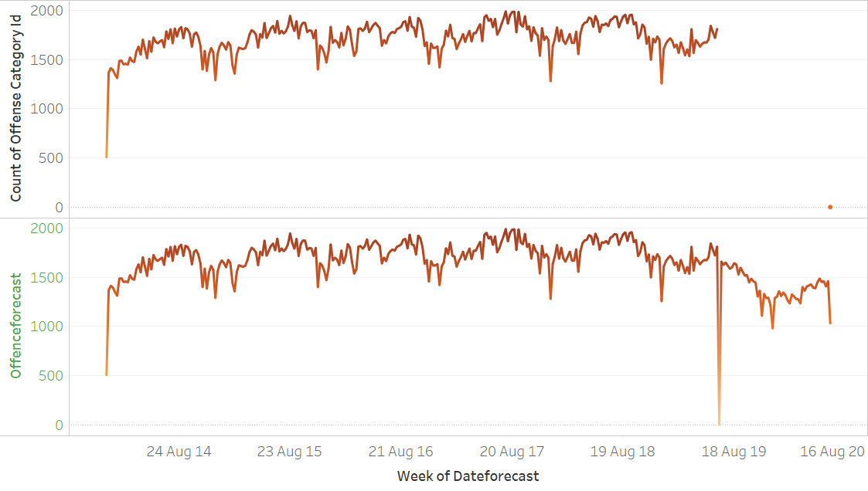

1. Finally, with Flask, I exposed one of the dashboards as html file which can be accessed via browser. Although this is done in local machine as follows:

* Create py file with following code:

from flask import Flask, render_template

import pygal

app = Flask(__name__)

@app.route('/tab')

def tab():

return render_template('tab.html')

if __name__ == '__main__':

app.run(debug=True)

* Run the above code to get the local IP:

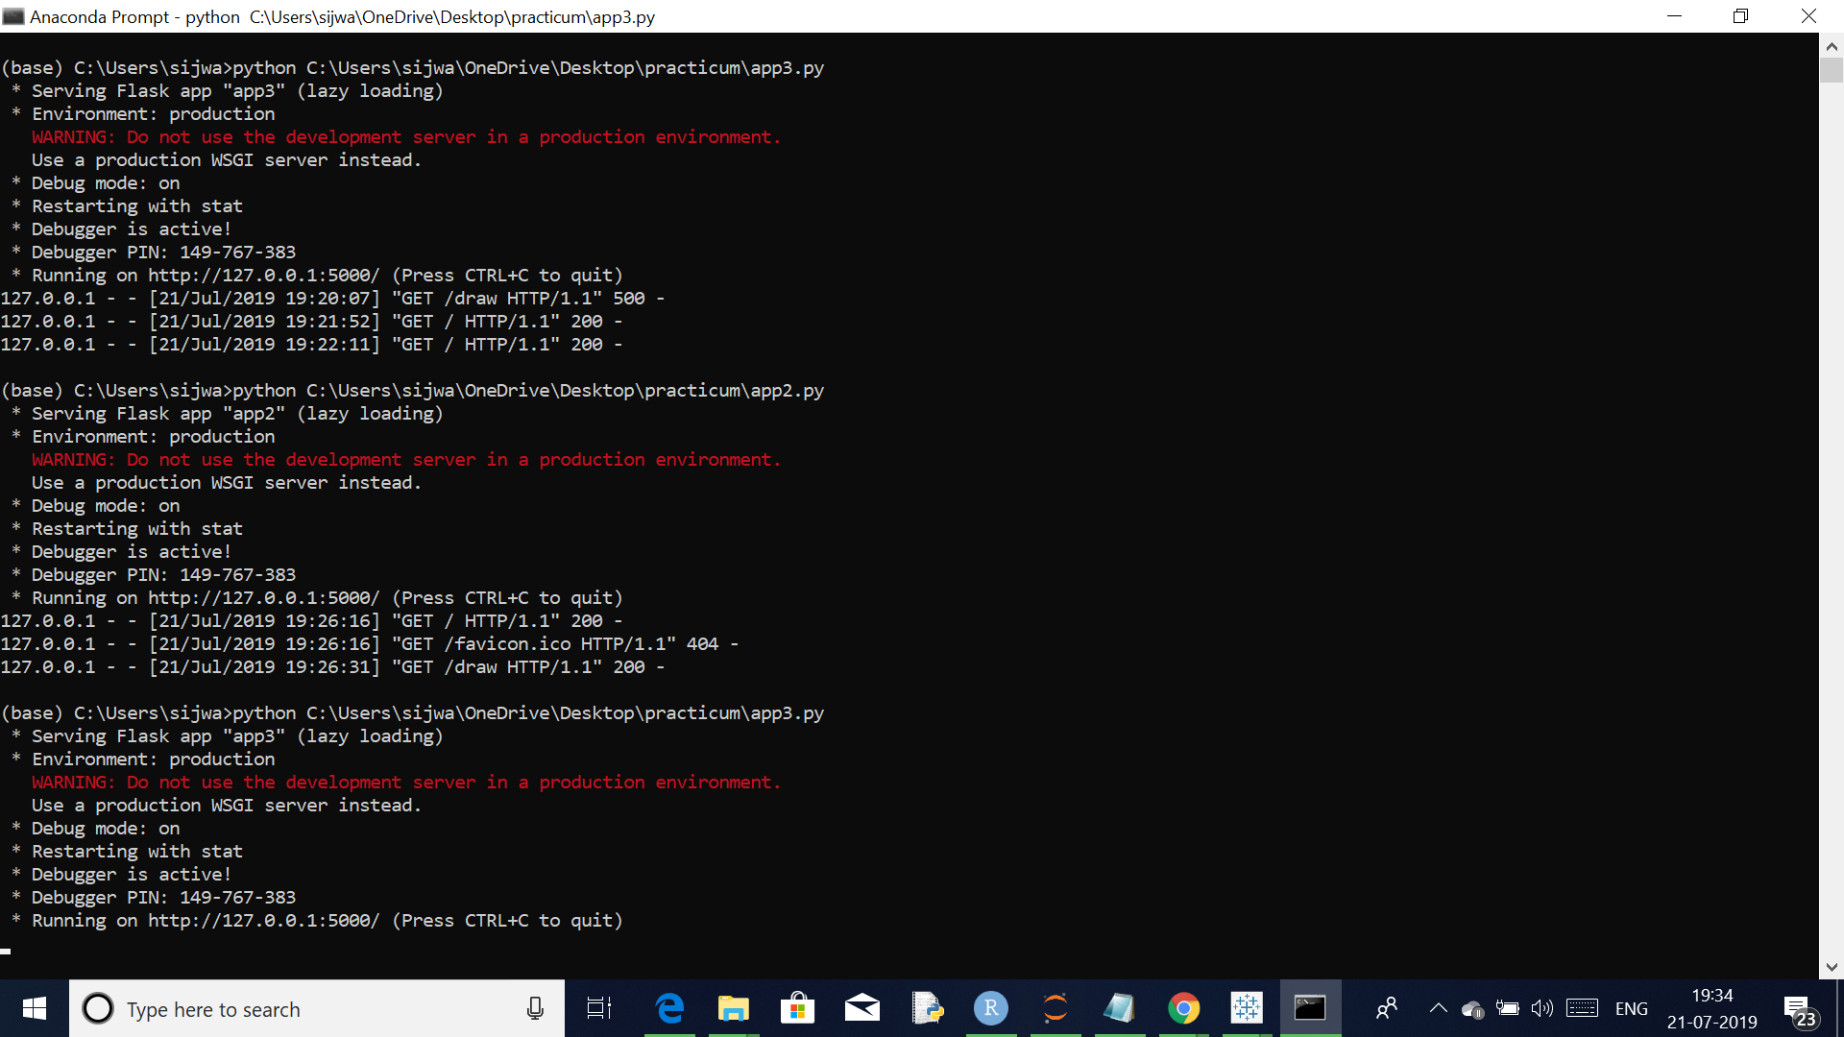

* Save one of the Tableau Dashboard in Public Domain and extract the embedded HTML code, to create following tab.html file:

<!doctype html>

<html>

<head>

<title>First app</title>

</head>

<body>

<div>

i<div class='tableauPlaceholder' id='viz1563691639079' style='position: relative'><noscript><a href='#'><img alt=' ' src='https:&#47;&#47;public.tableau.com&#47;static&#47;images&#47;As&#47;Assignmentfinal_15636915919800&#47;SubCategory&#47;1_rss.png' style='border: none' /></a></noscript><object class='tableauViz' style='display:none;'><param name='host_url' value='https%3A%2F%2Fpublic.tableau.com%2F' /> <param name='embed_code_version' value='3' /> <param name='site_root' value='' /><param name='name' value='Assignmentfinal_15636915919800&#47;SubCategory' /><param name='tabs' value='no' /><param name='toolbar' value='yes' /><param name='static_image' value='https:&#47;&#47;public.tableau.com&#47;static&#47;images&#47;As&#47;Assignmentfinal_15636915919800&#47;SubCategory&#47;1.png' /> <param name='animate_transition' value='yes' /><param name='display_static_image' value='yes' /><param name='display_spinner' value='yes' /><param name='display_overlay' value='yes' /><param name='display_count' value='yes' /><param name='filter' value='publish=yes' /></object></div> <script type='text/javascript'> var divElement = document.getElementById('viz1563691639079'); var vizElement = divElement.getElementsByTagName('object')[0]; vizElement.style.width='100%';vizElement.style.height=(divElement.offsetWidth*0.75)+'px'; var scriptElement = document.createElement('script'); scriptElement.src = 'https://public.tableau.com/javascripts/api/viz_v1.js'; vizElement.parentNode.insertBefore(scriptElement, vizElement); </script> </div>

</body>

</html>

* Finally view the dashboard in browser with ip as: <http://127.0.0.1:5000/tab>

